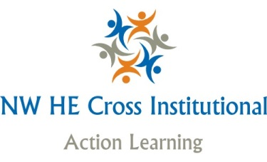

Confirmation of place on Action Learning Set Programme

Good afternoon

You recently completed an online application to participate in Cross Institutional North West Action Learning.

We are delighted to advise that you have successfully secured a place and will be joining colleagues from 7 other universities – Liverpool, Chester, Liverpool John Moores, Manchester. UCLAN and Cumbria and Lancaster - to participate in action learning. The main aim is to provide a space for women from participating universities to support each other to overcome work and career related challenges.
What next?
During September the facilitators will be organising participants into mixed action learning sets. We will then all meet for the launch and first set meeting on 12th October (see below). On this day we will be welcoming participants, getting to know each other, demonstrating the action learning approach and commencing the action learning. Following this date, your set will participate in action learning on three further occasions. At the last meeting in June 2017 we will ask you for your feedback to help enhance this development opportunity further.

Meeting dates

Launch of North West Action Learning for Women incorporating the first action learning meeting | University of Liverpool | 12th October 2016 | 10.00 am – 1.00 pm
Second action learning meeting | University of Cumbria | 10th January 2017 | 10.00 am – 1.00 pm
Third action learning set meeting | University of Manchester | 26th April 2017 | 10.00 am – 1.00 pm
Evaluation and feedback and fourth action learning set meeting | Liverpool John Moores | 8th June 2017 | 10.00 am – 1.00 pm

Attendance and Commitment

If you are unable to commit to at least three of the dates, we would urge you to give up your place on this occasion so that it can be taken by another applicant. As we only have limited places available, we have many on the waiting list that would value this opportunity.

News about North West Action Learning Project to date

Due to the success of last year’s cross-institutional action learning initiative, the project team were successful in acquiring funding from the Leadership Foundation to evaluate the value of action learning to participants and to develop a best practice guide to enable other regions across the UK to undertake similar initiatives. This piece of work will be shared with you at our first meeting on 12th October.

Further Information

For more information on the initiative and approach used visit:
http://actionlearn.weebly.com
Further communications will be posted to this website and you will receive confirmation of any new posts via email.

